Get responses tailored to you
Log in to get answers based on saved chats, plus create images and upload files.
Log in
🏕️ Ajman Camping Spots for Motorhomes (Iveco & Similar RVs)
Ajman might be the smallest emirate in the UAE, but it offers surprisingly peaceful and scenic camping opportunities—especially for motorhome travelers using vehicles like Iveco campers, caravans, and RV conversions. Whether you're looking for beachfront relaxation or desert solitude, Ajman delivers a calm, less crowded experience compared to other emirates.

🌊 1. Al Zorah Beach – Coastal Camping Experience
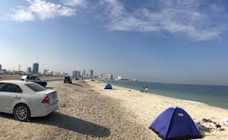
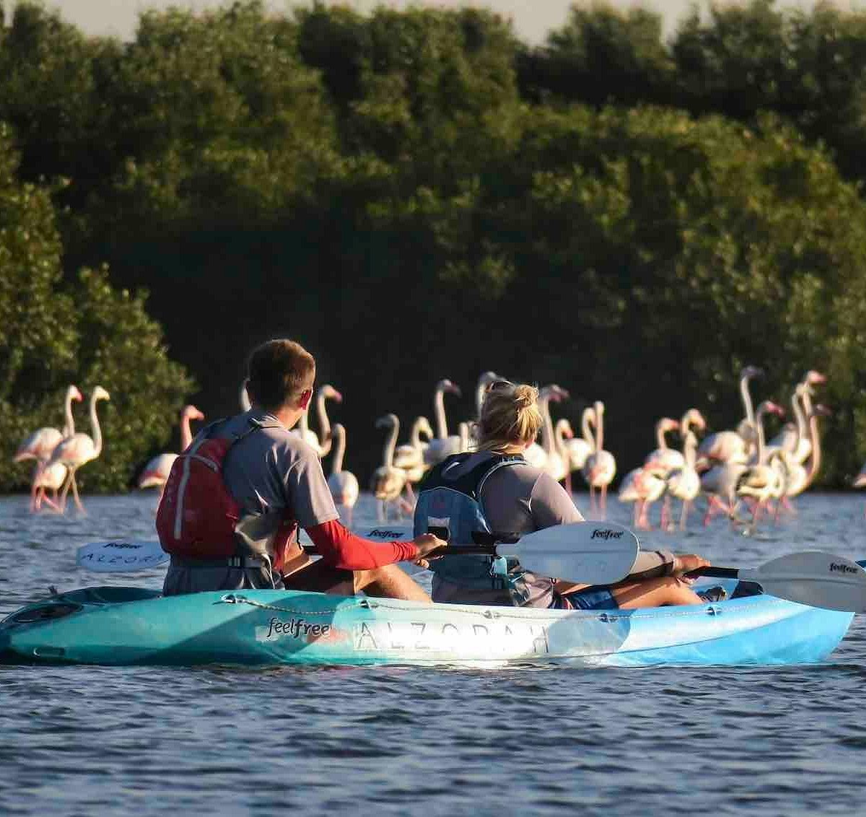
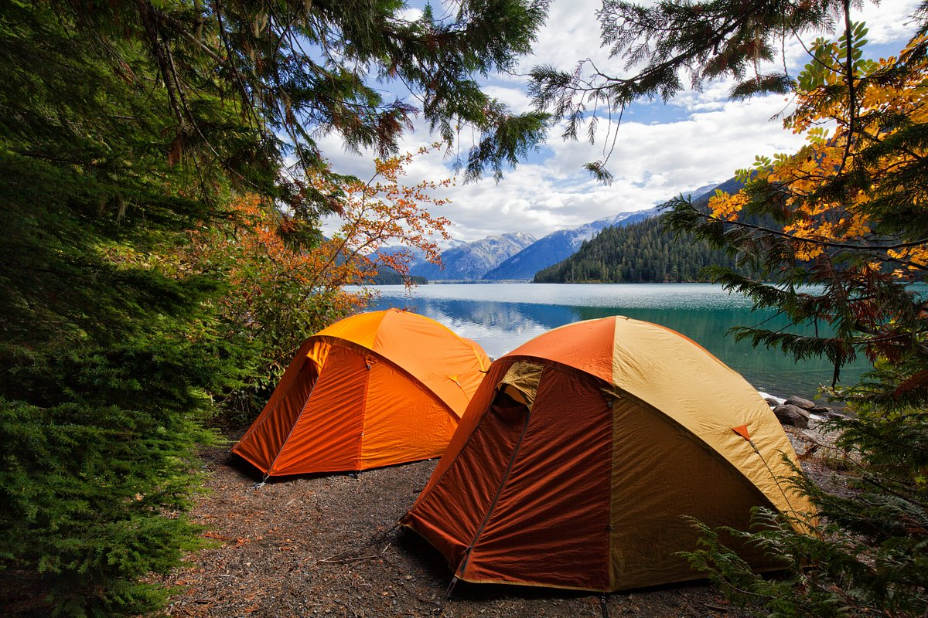
4
Located in the serene Al Zorah area, this is one of the best places in Ajman for motorhome camping.
Why it's great:
- Direct access for motorhomes like Iveco campers
- Quiet, clean beachfront with stunning sunsets
- Close to mangroves and birdwatching areas
- Easy parking on compact sand areas
Tips:
- Ideal for weekend overnight stays
- Bring leveling blocks—sand can be soft in some areas
- No official facilities, so carry water and waste tanks

🌴 2. Ajman Corniche – Urban Beach Camping (Short Stay)
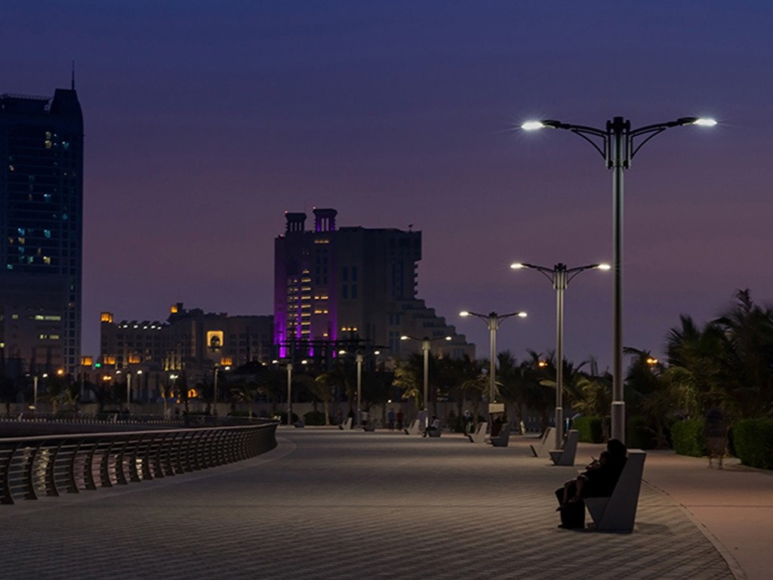
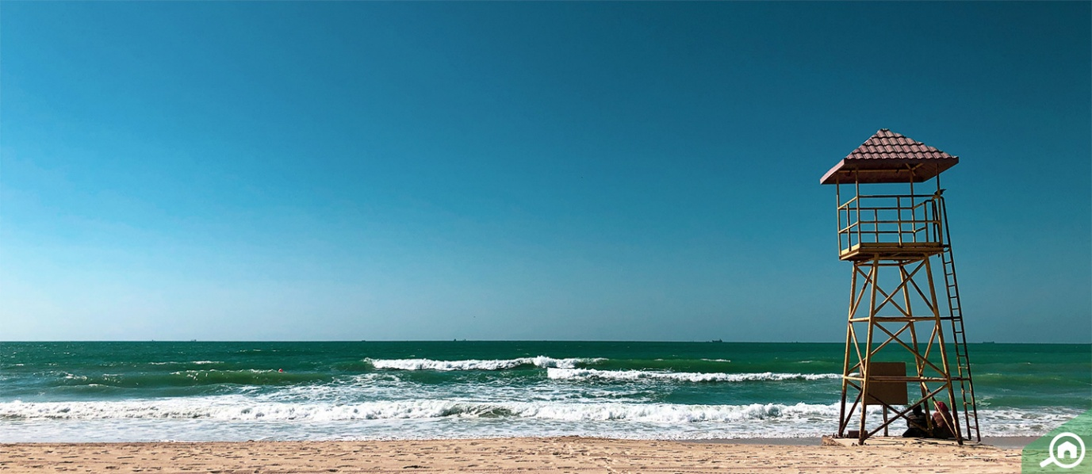
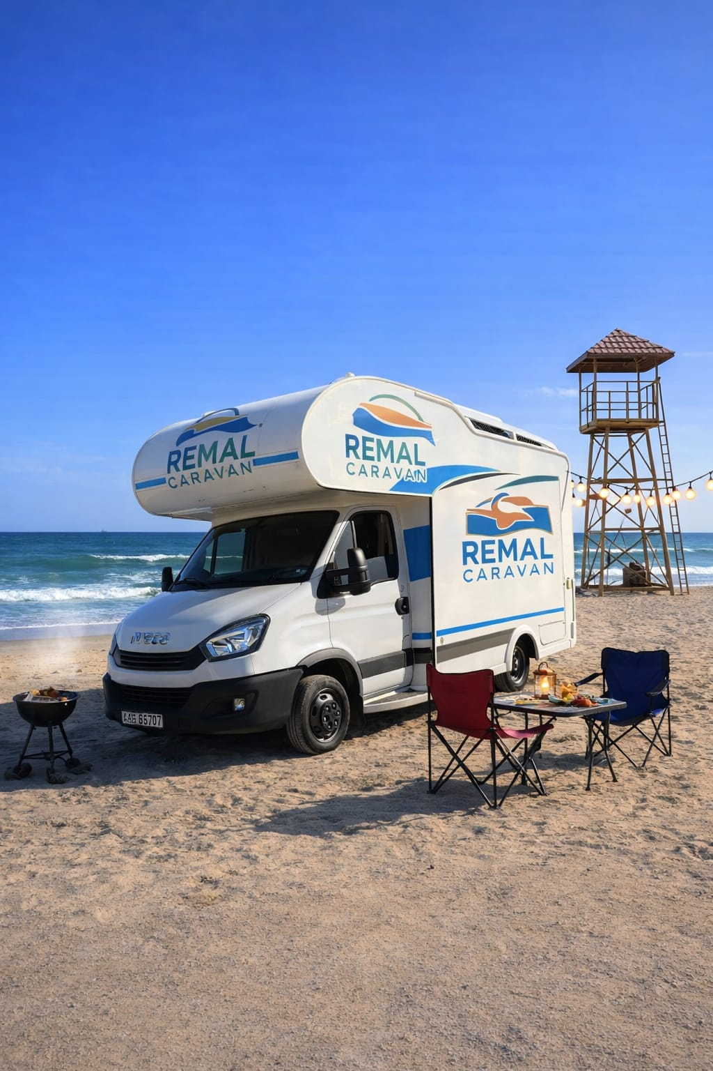
4
The Ajman Corniche offers a more lively atmosphere with easy access to restaurants and cafes.
Why it's great:
- Perfect for quick stops and evening setups
- Well-lit and safe area
- Food, supermarkets, and mosques nearby
Limitations:
- Overnight camping is not always permitted, so use discretion
- Best suited for short-term stays or day camping

🏜️ 3. Al Tallah Desert Area – Off-Road Desert Camping
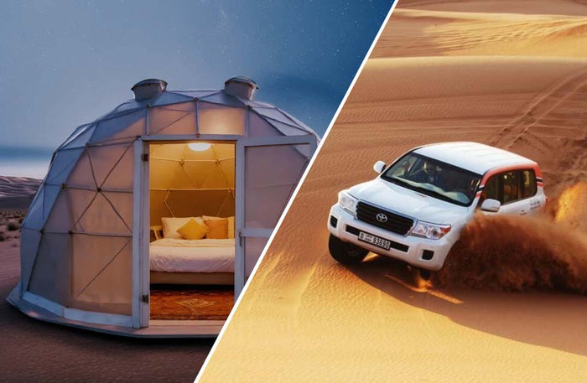

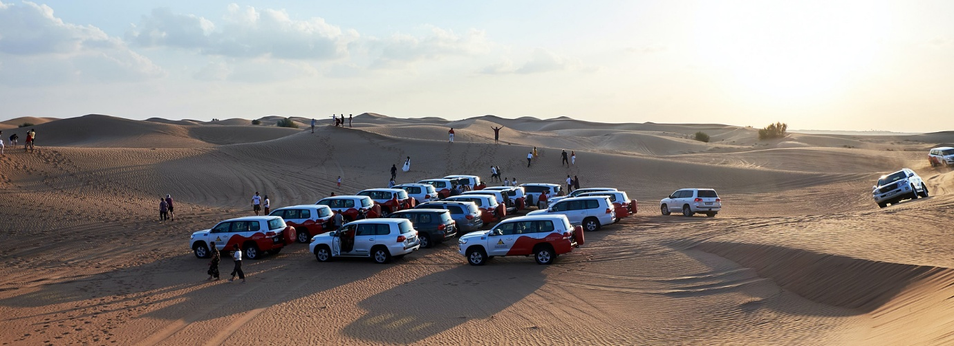
4
If you want a true desert experience, head toward Al Tallah.
Why it's great:
- Wide open space for self-sufficient motorhomes
- Perfect for BBQs, bonfires, and stargazing
- Low crowd density compared to Dubai deserts
Important notes:
- Suitable for 4x4 motorhomes or Iveco Daily 4x4 setups
- Avoid deep dunes unless experienced
- Carry recovery gear (traction boards, compressor)

🌿 4. Al Zorah Mangroves – Nature & Kayaking Escape
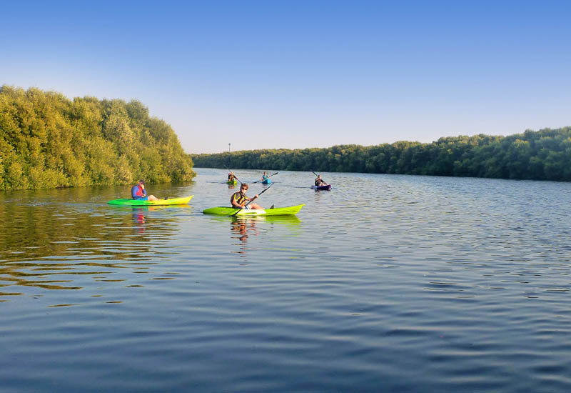
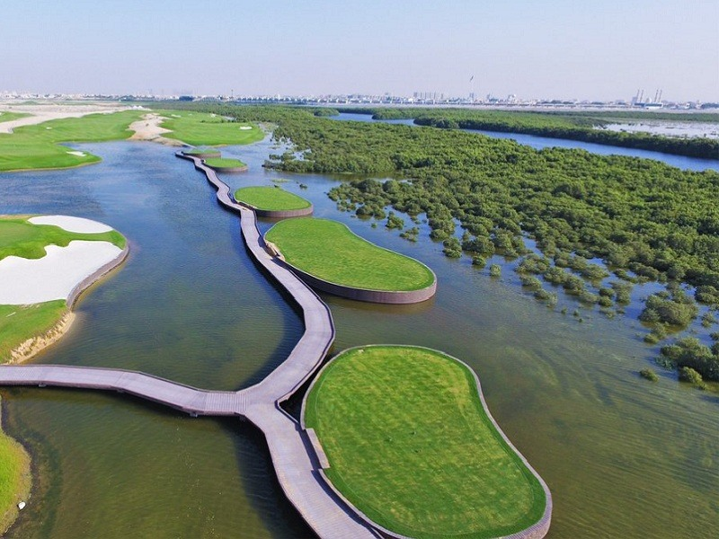

4
Close to Al Zorah beach, the Al Zorah Mangroves provide a unique eco-camping vibe.
Highlights:
- Kayaking through mangrove channels
- Flamingo and bird watching
- Peaceful environment for families
Motorhome suitability:
- Park nearby on firm ground
- Ideal for day camping + evening relaxation

🚐 Motorhome Camping Tips in Ajman
- Vehicle Type: Iveco Daily campers, Sprinter vans, and converted caravans are ideal
- Water & Power: No hookups—fully self-contained setup required
- Waste Disposal: Use proper disposal stations (Sharjah/Dubai if needed)
- Respect Rules: Avoid blocking public access and follow municipality guidelines
- Best Season: October to April (cooler weather)

🌟 Final Thoughts
Ajman is perfect if you want quiet, low-key camping with your motorhome—away from heavy crowds. Whether you park along the peaceful beaches of Al Zorah or venture into the desert outskirts, it’s an excellent destination for Iveco-style camper adventures.

If you want, I can also:
- Add map locations + GPS pins
- Customize this article with your “Remal Caravan” branding
- Include your vehicle photos edited into these locations

Voice

Ajman Motorhome Camping
You’re viewing user-generated content that may be unverified or unsafe.
Report
🏕️ Ajman Camping Spots for Motorhomes (Iveco & Similar RVs)
Ajman might be the smallest emirate in the UAE, but it offers surprisingly peaceful and scenic camping opportunities—especially for motorhome travelers using vehicles like Iveco campers, caravans, and RV conversions. Whether you're looking for beachfront relaxation or desert solitude, Ajman delivers a calm, less crowded experience compared to other emirates.

🌊 1. Al Zorah Beach – Coastal Camping Experience

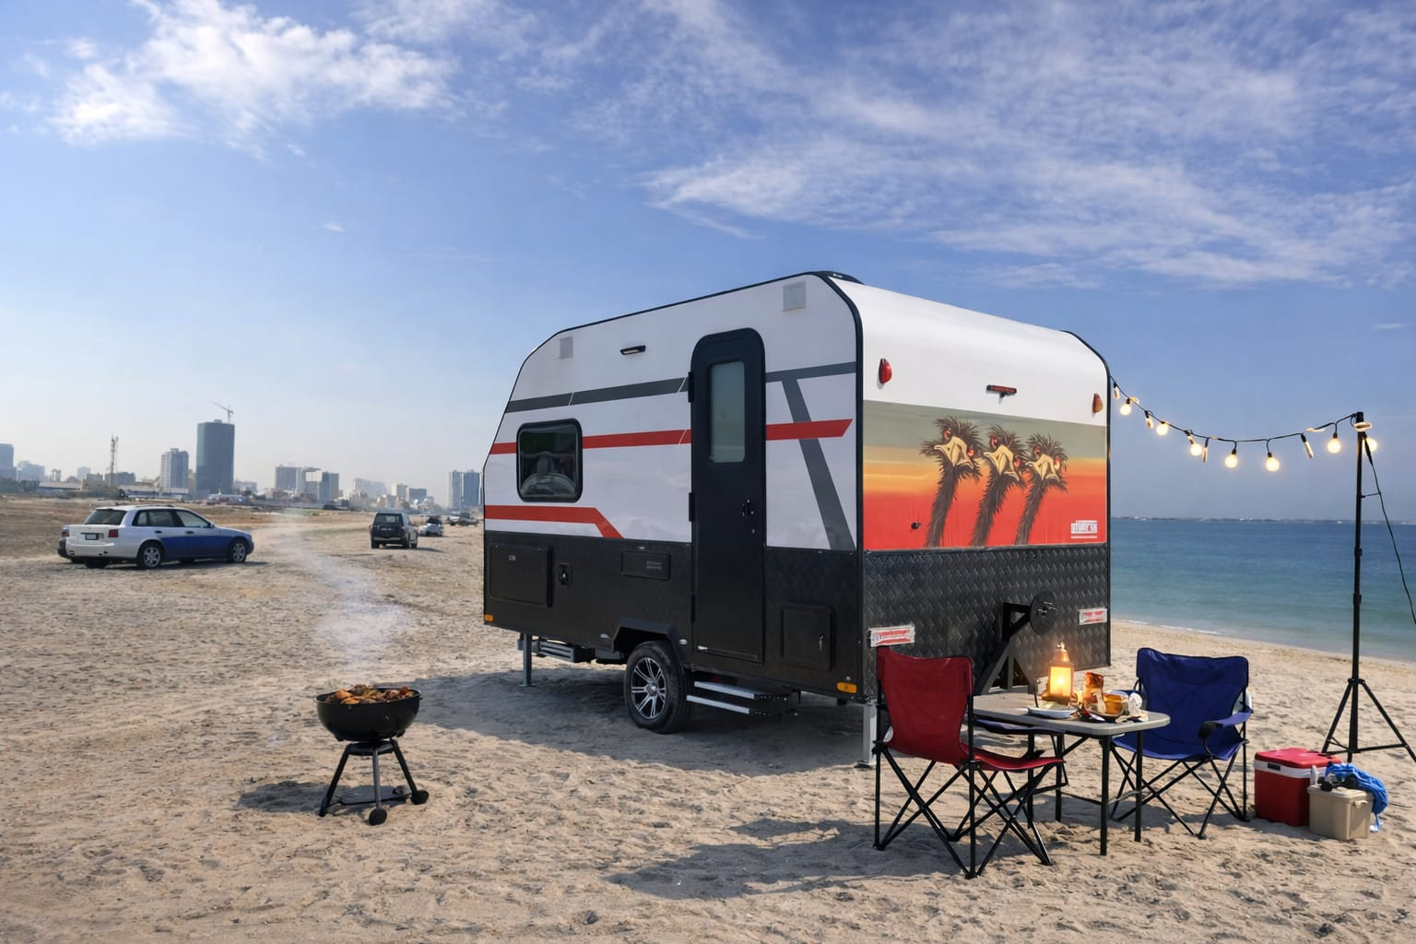Sites


4
Located in the serene Al Zorah area, this is one of the best places in Ajman for motorhome camping.
Why it's great:
- Direct access for motorhomes like Iveco campers
- Quiet, clean beachfront with stunning sunsets
- Close to mangroves and birdwatching areas
- Easy parking on compact sand areas
Tips:
- Ideal for weekend overnight stays
- Bring leveling blocks—sand can be soft in some areas
- No official facilities, so carry water and waste tanks

🌴 2. Ajman Corniche – Urban Beach Camping (Short Stay)



4
The Ajman Corniche offers a more lively atmosphere with easy access to restaurants and cafes.
Why it's great:
- Perfect for quick stops and evening setups
- Well-lit and safe area
- Food, supermarkets, and mosques nearby
Limitations:
- Overnight camping is not always permitted, so use discretion
- Best suited for short-term stays or day camping

🏜️ 3. Al Tallah Desert Area – Off-Road Desert Camping



4
If you want a true desert experience, head toward Al Tallah.
Why it's great:
- Wide open space for self-sufficient motorhomes
- Perfect for BBQs, bonfires, and stargazing
- Low crowd density compared to Dubai deserts
Important notes:
- Suitable for 4x4 motorhomes or Iveco Daily 4x4 setups
- Avoid deep dunes unless experienced
- Carry recovery gear (traction boards, compressor)

🌿 4. Al Zorah Mangroves – Nature & Kayaking Escape



4
Close to Al Zorah beach, the Al Zorah Mangroves provide a unique eco-camping vibe.
Highlights:
- Kayaking through mangrove channels
- Flamingo and bird watching
- Peaceful environment for families
Motorhome suitability:
- Park nearby on firm ground
- Ideal for day camping + evening relaxation

🚐 Motorhome Camping Tips in Ajman
- Vehicle Type: Iveco Daily campers, Sprinter vans, and converted caravans are ideal
- Water & Power: No hookups—fully self-contained setup required
- Waste Disposal: Use proper disposal stations (Sharjah/Dubai if needed)
- Respect Rules: Avoid blocking public access and follow municipality guidelines
- Best Season: October to April (cooler weather)

🌟 Final Thoughts
Ajman is perfect if you want quiet, low-key camping with your motorhome—away from heavy crowds. Whether you park along the peaceful beaches of Al Zorah or venture into the desert outskirts, it’s an excellent destination for Iveco-style camper adventures.

If you want, I can also:
- Add map locations + GPS pins
- Customize this article with your “Remal Caravan” branding
- Include your vehicle photos edited into these locations

